**EMPLOYEE MANAGEMENT SYSTEM**

**TABLE OF CONTENTS**

|  |  |  |
| --- | --- | --- |
| **CHAPTER** | **TITLE** | **PAGE NO** |
|  | **ABSTRACT** |  |
|  | **INTRODUCTION** |  |
|  | * 1. General Introduction |  |
|  | * 1. Project Objectives |  |
|  | * 1. Problem Statement |  |
|  | **SYSTEM** **PROPOSAL** |  |
|  | * 1. Existing System |  |
|  | * + 1. Disadvantages |  |
|  | * 1. Proposed System |  |
|  | 2.2.1 Advantages |  |
|  | * 1. Literature Survey |  |
|  | **SYSTEM DIAGRAMS** |  |
|  | * 1. Case Diagram |  |
|  | * 1. System Architecture Diagram |  |
|  | * 1. ER diagram |  |
|  | * 1. Flow Diagrams |  |
|  | * 1. Sequence Diagram |  |
|  | * 1. Activity Diagram |  |
|  | * 1. Class Diagram |  |
|  | **IMPLEMENTATION** |  |
|  | * 1. Modules |  |
|  | * 1. Modules Description |  |
|  | **SYSTEM** **REQUIREMENTS** |  |
|  | * 1. Hardware Requirements |  |
|  | * 1. Software Requirements |  |
|  | * 1. Software Description |  |
|  | * 1. Testing of Products |  |
|  | **CONCLUSION** |  |
| **7.** | **FUTURE** **ENHANCEMENT** |  |
| **8.** | **SAMPLE** **CODING** |  |
| **9.** | **SAMPLE** **SCREENSHOT** |  |
| **10.** | **REFERENCES** |  |

**Table of Diagram**

|  |  |  |
| --- | --- | --- |
| Image No | Image Name | Page number |
| 3.1 | Case diagram |  |
| 3.2 | System Architectural diagram |  |
| 3.3 | ER diagram |  |
| 3.4 | Level 0 |  |
| 3.5 | Level 1 |  |
| 3.6 | Level 2 |  |
| 3.7 | Sequence Diagram |  |
| 3.8 | Activity Diagram |  |
| 3.9 | Class Diagram |  |

**Table of Symbols**

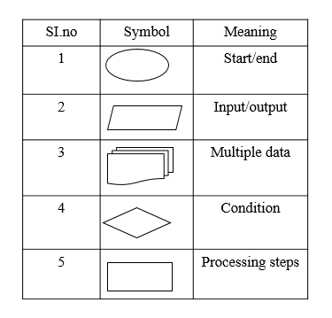

**ABSTRACT**

The Employee Management System (EMS) is a software application designed to help organizations manage their workforce effectively. It provides a centralized platform for storing and organizing employee information, including personal details, job roles, and performance metrics. The system enables Admin departments to automate various processes such as hired date, position, department, status, salary, skills, and performance evaluations. With a user-friendly interface, the EMS allows HR personnel to quickly access, update, and analyze employee data, facilitating better decision-making and improved operational efficiency.

By streamlining these functions, the EMS not only enhances productivity but also fosters a positive work environment by ensuring that employee needs are addressed promptly and accurately.

Consolidates employee information in a single platform, making it easy to access and manage records. Also simplifies hiring by automating job postings, applicant tracking, and on boarding processes. The Employee Management System is an innovative solution that addresses the complexities of human resource management, promotes organizational efficiency, and supports strategic workforce planning. Its implementation can lead to significant improvements in employee engagement and overall organizational performance.

**CHAPTER 1**

**INTRODUCTION**

* 1. **General Introduction:**

The existing systems for managing employee information often present several disadvantages that hinder organizational efficiency and employee satisfaction. Many organizations still rely on manual processes or outdated spreadsheet applications, which can lead to significant data inaccuracies and inconsistencies. Maintaining employee records in physical files or disjointed digital formats increases the risk of losing critical information and makes it difficult to retrieve data promptly. This inefficiency can result in time-consuming administrative tasks, as HR personnel may spend excessive amounts of time searching for documents or manually updating records, ultimately detracting from more strategic functions.

Moreover, the lack of integration in existing systems often leads to poor communication and collaboration across departments. Employees may face challenges in accessing their own information, such as pay details or performance reviews, creating frustration and disengagement. Additionally, performance evaluations tend to be sporadic and informal, which can result in employees feeling undervalued or uncertain about their career progression. This ad hoc approach to performance management can stifle development opportunities and inhibit employees from reaching their full potential.

Security is another critical concern, as many existing systems do not adequately protect sensitive employee data. Relying on paper records or unsecured digital storage increases vulnerability to data breaches and unauthorized access, potentially compromising employee privacy and exposing organizations to legal liabilities. Furthermore, the lack of compliance features in many traditional systems can lead to regulatory issues, as organizations may struggle to maintain accurate records or generate necessary documentation for audits.

Ultimately, these disadvantages underscore the urgent need for a more comprehensive and automated Employee Management System. Without such improvements, organizations risk diminished productivity, decreased employee morale, and challenges in meeting compliance requirements, which can adversely affect overall business performance and growth.

**CLOUD COMPUTING**

Cloud computing is a transformative technology that enables users to access and store data and applications over the internet instead of relying on local servers or personal computers. By leveraging remote servers hosted on the internet, cloud computing offers scalability, flexibility, and cost-effectiveness, allowing businesses and individuals to manage resources on-demand. Users can easily collaborate in real-time, access applications from anywhere, and scale their computing power according to their needs. With various deployment models—public, private, and hybrid—cloud computing caters to diverse requirements, enhancing efficiency and promoting innovation across industries. This paradigm shift not only streamlines operations but also drives digital transformation, making it an essential component of modern IT infrastructure.

* 1. **Objectives:**

**The main objective of our project is,**

* + The respective employee to enter the frame page with proper ID and Password.
  + To fill the data about him/her for the admin point of view, also that employee data convert her/his name pdf for the storing process
  + Admin can enter to view the employee details and give ID for that employee and her/his name pdf format.
  + To avoid the unnecessary entry, we have the verification of checking the employee file with name and size.
  + To have the secured cloud storage when the admin uploading the file it will upload to the database in encrypted format.
  + All files have the unique id like secret key by using that only the admin can upload.
  + And employee can download the file with proper secret key.
  1. **Problem Statement:**

The traditional methods of managing employee information within organizations often lead to significant inefficiencies, inaccuracies, and administrative burdens. Many organizations rely on manual processes, paper-based records, or basic spreadsheet applications to handle critical admin functions such as employee data management. These outdated systems are prone to errors, making it difficult to maintain accurate and up-to-date records, which can hinder decision-making and impact employee satisfaction.

Additionally, the lack of a centralized platform results in fragmented information, complicating data retrieval and communication across departments. Employees often face challenges in accessing their own information, leading to frustration and disengagement.

This system should address these challenges by centralizing employee data, streamlining administrative processes, enhancing communication, and ensuring compliance, ultimately fostering a more efficient and engaged workforce.

**CHAPTER 2**

**SYSTEM PROPOSAL**

**2.1 EXISTING SYSTEM**

* The existing Employee Management System often relies on traditional manual processes or basic spreadsheet applications to manage employee information, leading to various challenges and inefficiencies.
* Many organizations still use paper-based records or disparate systems, making it difficult to maintain accurate and up-to-date employee data.
* Furthermore, the lack of a centralized database makes it challenging to retrieve information quickly, hindering admin personnel's ability to respond to inquiries or generate reports.
* Communication between departments can become cumbersome, as employees may have to navigate multiple channels to access the information they need.
* Additionally, performance rating and status mechanisms are often ad hoc, resulting in a lack of structured development opportunities for employees.

**2.1.1 DISADVANTAGES**

* Many systems can be complex and not user-friendly, leading to frustration among employees and management.
* If users find it difficult to navigate the system, it can result in underutilization of its features.
* May struggle to integrate with other tools and platforms used within the organization, leading to inefficiencies and data silos.
* Organizations may also incur ongoing costs for maintenance and updates.
* Storing sensitive employee information can expose organizations to unauthorized or untruthful person Data breaches can lead to serious legal and financial consequences.
  1. **PROPOSED SYSTEM**
  + The respective employee to enter the frame page with proper ID and Password.
  + To fill the data about him/her for the admin point of view, also that employee data convert her/his name pdf for the storing process
  + Admin can enter to view the employee details and give ID for that employee and her/his name pdf format.
  + In our proposed system Implements the Encryption algorithm to encrypt data, the cloud storage provider would generate a symmetric encryption key using a cryptographically secure random number generator.
  + To avoid the unnecessary entry, we have the verification of checking the employee file with name and size. Otherwise that employee only enter her/his details only.
  + To have the secured cloud storage when the admin uploading the file it will upload to the database in encrypted format.
  + All files have the unique id like secret key by using that only the admin can upload.
  + Finally, the cloud storage provider would encrypt the symmetric encryption key using the public key of the data owner.
  + And employee can download the file with proper secret key.

**2.2.1 ADVANTAGES**

* One of the primary benefits is the centralization of employee data, allowing HR departments to maintain accurate and up-to-date records in a single database.
* This accessibility streamlines various administrative tasks, and handling performance evaluations, which reduces the likelihood of errors and saves valuable time.
* Automated processes, such as reminders for performance status and update data ,further improve productivity by minimizing manual workload and enabling Admin professionals to focus on strategic initiatives rather than routine tasks.
* An EMS facilitates enhanced communication and collaboration across departments.
* Another significant advantage is the ability to generate insightful reports and analytics

**2.3 LITERATURE SURVEY:**

# **2.3.1 Exploring Role of Technology Performance Expectancy, Application Effort Expectancy, Perceived Risk and Perceived Cost On Digital Behavioral Intention of GoFood Users**

# **Author***:* Tannady, H., Dewi, C. S., & Gilbert.

# **Methodology**

This study explores the influence of key technological factors—performance expectancy, application effort expectancy, perceived risk, and perceived cost—on the digital behavioral intention of GoFood users. As a leading food delivery service, GoFood faces a rapidly evolving market where user engagement is critical. Performance expectancy refers to the perceived benefits of using the app, such as convenience and speed of service. Application effort expectancy addresses the perceived ease of use and accessibility of the platform. Perceived risk involves concerns about data privacy and security, while perceived cost relates to both monetary and non-monetary expenditures associated with using the service. This research employs a quantitative approach to analyze user responses and identify significant predictors of user intention. Findings indicate that performance expectancy and application effort expectancy positively influence user engagement, whereas perceived risk and perceived cost serve as barriers to adoption. The study concludes by providing recommendations for GoFood to enhance user experience and address concerns, ultimately driving greater user adoption and satisfaction.

**Disadvantages:**

# Users may be apprehensive about sharing personal information and payment details, leading to decreased trust in the platform.

# Over-reliance on digital platforms can alienate users who prefer traditional methods of ordering, potentially limiting the user base.

# **2.3.2 Green human resources management practices, leadership style and employee engagement: Green banking context**

# **Author***:* Noor, J., Tunnufus, Z., Handrian, V. Y., & Yumhi, Y.

# **Methodology**

Green Human Resources Management (GHRM) practices refer to the strategies and policies implemented by organizations to promote environmental sustainability while enhancing employee performance and engagement. This approach integrates eco-friendly practices into various HR functions, such as recruitment, training, and performance management, fostering a culture of sustainability within the organization. Leadership styles that prioritize environmental responsibility and employee engagement are critical in driving GHRM initiatives. Transformational leadership, for instance, encourages a shared vision of sustainability and inspires employees to adopt green practices. This paper examines the relationship between GHRM practices, leadership styles, and employee engagement, highlighting how effective green initiatives can enhance organizational performance and employee satisfaction. However, implementing GHRM is not without challenges, and the paper also discusses potential disadvantages.

**Disadvantages:**

# Employees and management may resist changes associated with GHRM practices, particularly if they perceive them as disruptive to existing processes or unnecessary.

# If leadership does not consistently model and commit to green practices, employee engagement in these initiatives may wane, undermining their effectiveness.

# **2.3.3 Analysis Of The Influence Of E-Word Of Mouth, Brand Image And E-Service Quality On Repurchase Intention Of Digital Bank Customers.**

# **Author***:* Dharmawan, D., Judijanto, L., Rahmi, N., & Lotte, L. N. A.

# **Methodology**

This study analyzes the influence of electronic word of mouth (e-WOM), brand image, and e-service quality on the repurchase intention of digital bank customers. With the rapid growth of digital banking, understanding these factors is essential for enhancing customer loyalty and retention. E-WOM, characterized by online reviews and customer recommendations, significantly impacts customer perceptions and behaviors. Brand image plays a crucial role in shaping customer trust and loyalty, while e-service quality determines the overall customer experience in the digital banking environment. This research employs a quantitative approach, utilizing surveys to gather data from digital bank users. The findings indicate that positive e-WOM, a strong brand image, and high e-service quality significantly enhance repurchase intentions among digital bank customers. These insights provide valuable implications for digital banking strategies aimed at increasing customer engagement and loyalty.

**Disadvantages:**

# The rapid evolution of digital banking technology and consumer preferences may render findings outdated quickly, necessitating ongoing research.

# A focus on quantitative data might overlook qualitative insights that could provide a deeper understanding of customer motivations and behaviors

# **2.3.4 Judul: Peran Social Media Marketing dan Brand Awareness Terhadap Purchase Intention Produk Es Teh Indonesia**

# **Author***:* Taufik, Y., Sari, A. R., Zakhra, A., Ayesha, I., Siregar, A. P., Kusnadi, I. H., & Tannady, H

# **Methodology**

This study analyzes the influence of electronic word of mouth (e-WOM), brand image, and e-service quality on the repurchase intention of digital bank customers. With the rapid growth of digital banking, understanding these factors is essential for enhancing customer loyalty and retention. E-WOM, characterized by online reviews and customer recommendations, significantly impacts customer perceptions and behaviors. Brand image plays a crucial role in shaping customer trust and loyalty, while e-service quality determines the overall customer experience in the digital banking environment. This research employs a quantitative approach, utilizing surveys to gather data from digital bank users. The findings indicate that positive e-WOM, a strong brand image, and high e-service quality significantly enhance repurchase intentions among digital bank customers. These insights provide valuable implications for digital banking strategies aimed at increasing customer engagement and loyalty.

Penelitian ini mengkaji peran social media marketing dan brand awareness dalam mempengaruhi niat beli produk es teh di Indonesia. Dengan meningkatnya penggunaan media sosial di kalangan konsumen, perusahaan es teh berupaya memanfaatkan platform ini untuk meningkatkan kesadaran merek dan menarik perhatian pelanggan. Melalui pendekatan kuantitatif, penelitian ini mengumpulkan data dari konsumen yang aktif menggunakan media sosial dan menganalisis pengaruh social media marketing serta brand awareness terhadap purchase intention. Hasil penelitian menunjukkan bahwa social media marketing secara signifikan meningkatkan brand awareness, yang pada gilirannya berdampak positif terhadap niat beli produk es teh.

Anomaly detection in a dynamic data stream is a

challenging task. The endless bound and high arriving rate of

data prohibits anomaly detection models to store all observations

in memory for processing. In addition, the dynamically moving

properties of the data stream exhibit concept drift. While recent

studies focus on feature extraction for anomaly detection, major-

ity of them assume data stream are static ignoring the possibility

of concept drift occurring. Anomaly detection models must

operate efﬁciently in order to deal with high volume and velocity

data, that is to have low complexity and to learn incrementally

from each arriving observation. Incremental learning allows the

model to adapt to concept drift. In cases where drifting rate

is higher than adaptation rate, the capability to detect concept

drift and retraining a new model is much preferable to minimize

the performance losses. In this paper, we propose MIR MAD,

an approach based on multiple incremental robust Mahalanobis

estimators that is efﬁcient, learns incrementally and has the

capability to detect concept drift. MIR MAD is fast, can be

initialized with small amount of data, and is able to estimate

the drift location on the data stream. Our empirical results

show that MIR MAD achieves state-of-the-art performance and

is signiﬁcantly faster. We also performed a case study to show

that detecting concept drift is critical to minimize the reductio

Anomaly detection in a dynamic data stream is a

challenging task. The endless bound and high arriving rate of

data prohibits anomaly detection models to store all observations

in memory for processing. In addition, the dynamically moving

properties of the data stream exhibit concept drift. While recent

studies focus on feature extraction for anomaly detection, major-

ity of them assume data stream are static ignoring the possibility

of concept drift occurring. Anomaly detection models must

operate efﬁciently in order to deal with high volume and velocity

data, that is to have low complexity and to learn incrementally

from each arriving observation. Incremental learning allows the

model to adapt to concept drift. In cases where drifting rate

is higher than adaptation rate, the capability to detect concept

drift and retraining a new model is much preferable to minimize

the performance losses. In this paper, we propose MIR MAD,

an approach based on multiple incremental robust Mahalanobis

estimators that is efﬁcient, learns incrementally and has the

capability to detect concept drift. MIR MAD is fast, can be

initialized with small amount of data, and is able to estimate

the drift location on the data stream. Our empirical results

show that MIR MAD achieves state-of-the-art performance and

is signiﬁcantly faster. We also performed a case study to show

that detecting concept drift is critical to minimize the reductio

Anomaly detection in a dynamic data stream is a

challenging task. The endless bound and high arriving rate of

data prohibits anomaly detection models to store all observations

in memory for processing. In addition, the dynamically moving

properties of the data stream exhibit concept drift. While recent

studies focus on feature extraction for anomaly detection, major-

ity of them assume data stream are static ignoring the possibility

of concept drift occurring. Anomaly detection models must

operate efﬁciently in order to deal with high volume and velocity

data, that is to have low complexity and to learn incrementally

from each arriving observation. Incremental learning allows the

model to adapt to concept drift. In cases where drifting rate

is higher than adaptation rate, the capability to detect concept

drift and retraining a new model is much preferable to minimize

the performance losses. In this paper, we propose MIR MAD,

an approach based on multiple incremental robust Mahalanobis

estimators that is efﬁcient, learns incrementally and has the

capability to detect concept drift. MIR MAD is fast, can be

initialized with small amount of data, and is able to estimate

the drift location on the data stream. Our empirical results

show that MIR MAD achieves state-of-the-art performance and

is signiﬁcantly faster. We also performed a case study to show

that detecting concept drift is critical to minimize the reductio

Anomaly detection in a dynamic data stream is a

challenging task. The endless bound and high arriving rate of

data prohibits anomaly detection models to store all observations

in memory for processing. In addition, the dynamically moving

properties of the data stream exhibit concept drift. While recent

studies focus on feature extraction for anomaly detection, major-

ity of them assume data stream are static ignoring the possibility

of concept drift occurring. Anomaly detection models must

operate efﬁciently in order to deal with high volume and velocity

data, that is to have low complexity and to learn incrementally

from each arriving observation. Incremental learning allows the

model to adapt to concept drift. In cases where drifting rate

is higher than adaptation rate, the capability to detect concept

drift and retraining a new model is much preferable to minimize

the performance losses. In this paper, we propose MIR MAD,

an approach based on multiple incremental robust Mahalanobis

estimators that is efﬁcient, learns incrementally and has the

capability to detect concept drift. MIR MAD is fast, can be

initialized with small amount of data, and is able to estimate

the drift location on the data stream. Our empirical results

show that MIR MAD achieves state-of-the-art performance and

is signiﬁcantly faster. We also performed a case study to show

that detecting concept drift is critical to minimize the reductio

Anomaly detection in a dynamic data stream is a

challenging task. The endless bound and high arriving rate of

data prohibits anomaly detection models to store all observations

in memory for processing. In addition, the dynamically moving

properties of the data stream exhibit concept drift. While recent

studies focus on feature extraction for anomaly detection, major-

ity of them assume data stream are static ignoring the possibility

of concept drift occurring. Anomaly detection models must

operate efﬁciently in order to deal with high volume and velocity

data, that is to have low complexity and to learn incrementally

from each arriving observation. Incremental learning allows the

model to adapt to concept drift. In cases where drifting rate

is higher than adaptation rate, the capability to detect concept

drift and retraining a new model is much preferable to minimize

the performance losses. In this paper, we propose MIR MAD,

an approach based on multiple incremental robust Mahalanobis

estimators that is efﬁcient, learns incrementally and has the

capability to detect concept drift. MIR MAD is fast, can be

initialized with small amount of data, and is able to estimate

the drift location on the data stream. Our empirical results

show that MIR MAD achieves state-of-the-art performance and

is signiﬁcantly faster. We also performed a case study to show

that detecting concept drift is critical to minimize the reduction

Anomaly detection in a dynamic data stream is a

challenging task. The endless bound and high arriving rate of

data prohibits anomaly detection models to store all observations

in memory for processing. In addition, the dynamically moving

properties of the data stream exhibit concept drift. While recent

studies focus on feature extraction for anomaly detection, major-

ity of them assume data stream are static ignoring the possibility

of concept drift occurring. Anomaly detection models must

operate efﬁciently in order to deal with high volume and velocity

data, that is to have low complexity and to learn incrementally

from each arriving observation. Incremental learning allows the

model to adapt to concept drift. In cases where drifting rate

is higher than adaptation rate, the capability to detect concept

drift and retraining a new model is much preferable to minimize

the performance losses. In this paper, we propose MIR MAD,

an approach based on multiple incremental robust Mahalanobis

estimators that is efﬁcient, learns incrementally and has the

capability to detect concept drift. MIR MAD is fast, can be

initialized with small amount of data, and is able to estimate

the drift location on the data stream. Our empirical results

show that MIR MAD achieves state-of-the-art performance and

is signiﬁcantly faster. We also performed a case study to show

that detecting concept drift is critical to minimize the reduction

Anomaly detection in a dynamic data stream is a

challenging task. The endless bound and high arriving rate of

data prohibits anomaly detection models to store all observations

in memory for processing. In addition, the dynamically moving

properties of the data stream exhibit concept drift. While recent

studies focus on feature extraction for anomaly detection, major-

ity of them assume data stream are static ignoring the possibility

of concept drift occurring. Anomaly detection models must

operate efﬁciently in order to deal with high volume and velocity

data, that is to have low complexity and to learn incrementally

from each arriving observation. Incremental learning allows the

model to adapt to concept drift. In cases where drifting rate

is higher than adaptation rate, the capability to detect concept

drift and retraining a new model is much preferable to minimize

the performance losses. In this paper, we propose MIR MAD,

an approach based on multiple incremental robust Mahalanobis

estimators that is efﬁcient, learns incrementally and has the

capability to detect concept drift. MIR MAD is fast, can be

initialized with small amount of data, and is able to estimate

the drift location on the data stream. Our empirical results

show that MIR MAD achieves state-of-the-art performance and

is signiﬁcantly faster. We also performed a case study to show

that detecting concept drift is critical to minimize the reduction

Anomaly detection in a dynamic data stream is a

challenging task. The endless bound and high arriving rate of

data prohibits anomaly detection models to store all observations

in memory for processing. In addition, the dynamically moving

properties of the data stream exhibit concept drift. While recent

studies focus on feature extraction for anomaly detection, major-

ity of them assume data stream are static ignoring the possibility

of concept drift occurring. Anomaly detection models must

operate efﬁciently in order to deal with high volume and velocity

data, that is to have low complexity and to learn incrementally

from each arriving observation. Incremental learning allows the

model to adapt to concept drift. In cases where drifting rate

is higher than adaptation rate, the capability to detect concept

drift and retraining a new model is much preferable to minimize

the performance losses. In this paper, we propose MIR MAD,

an approach based on multiple incremental robust Mahalanobis

estimators that is efﬁcient, learns incrementally and has the

capability to detect concept drift. MIR MAD is fast, can be

initialized with small amount of data, and is able to estimate

the drift location on the data stream. Our empirical results

show that MIR MAD achieves state-of-the-art performance and

is signiﬁcantly faster. We also performed a case study to show

that detecting concept drift is critical to minimize the reduction

Anomaly detection in a dynamic data stream is a

challenging task. The endless bound and high arriving rate of

data prohibits anomaly detection models to store all observations

in memory for processing. In addition, the dynamically moving

properties of the data stream exhibit concept drift. While recent

studies focus on feature extraction for anomaly detection, major-

ity of them assume data stream are static ignoring the possibility

of concept drift occurring. Anomaly detection models must

operate efﬁciently in order to deal with high volume and velocity

data, that is to have low complexity and to learn incrementally

from each arriving observation. Incremental learning allows the

model to adapt to concept drift. In cases where drifting rate

is higher than adaptation rate, the capability to detect concept

drift and retraining a new model is much preferable to minimize

the performance losses. In this paper, we propose MIR MAD,

an approach based on multiple incremental robust Mahalanobis

estimators that is efﬁcient, learns incrementally and has the

capability to detect concept drift. MIR MAD is fast, can be

initialized with small amount of data, and is able to estimate

the drift location on the data stream. Our empirical results

show that MIR MAD achieves state-of-the-art performance and

is signiﬁcantly faster. We also performed a case study to show

that detecting concept drift is critical to minimize the reduction

Anomaly detection in a dynamic data stream is a

challenging task. The endless bound and high arriving rate of

data prohibits anomaly detection models to store all observations

in memory for processing. In addition, the dynamically moving

properties of the data stream exhibit concept drift. While recent

studies focus on feature extraction for anomaly detection, major-

ity of them assume data stream are static ignoring the possibility

of concept drift occurring. Anomaly detection models must

operate efﬁciently in order to deal with high volume and velocity

data, that is to have low complexity and to learn incrementally

from each arriving observation. Incremental learning allows the

model to adapt to concept drift. In cases where drifting rate

is higher than adaptation rate, the capability to detect concept

drift and retraining a new model is much preferable to minimize

the performance losses. In this paper, we propose MIR MAD,

an approach based on multiple incremental robust Mahalanobis

estimators that is efﬁcient, learns incrementally and has the

capability to detect concept drift. MIR MAD is fast, can be

initialized with small amount of data, and is able to estimate

the drift location on the data stream. Our empirical results

show that MIR MAD achieves state-of-the-art performance and

is signiﬁcantly faster. We also performed a case study to show

that detecting concept drift is critical to minimize the reduction

Anomaly detection in a dynamic data stream is a

challenging task. The endless bound and high arriving rate of

data prohibits anomaly detection models to store all observations

in memory for processing. In addition, the dynamically moving

properties of the data stream exhibit concept drift. While recent

studies focus on feature extraction for anomaly detection, major-

ity of them assume data stream are static ignoring the possibility

of concept drift occurring. Anomaly detection models must

operate efﬁciently in order to deal with high volume and velocity

data, that is to have low complexity and to learn incrementally

from each arriving observation. Incremental learning allows the

model to adapt to concept drift. In cases where drifting rate

is higher than adaptation rate, the capability to detect concept

drift and retraining a new model is much preferable to minimize

the performance losses. In this paper, we propose MIR MAD,

an approach based on multiple incremental robust Mahalanobis

estimators that is efﬁcient, learns incrementally and has the

capability to detect concept drift. MIR MAD is fast, can be

initialized with small amount of data, and is able to estimate

the drift location on the data stream. Our empirical results

show that MIR MAD achieves state-of-the-art performance and

is signiﬁcantly faster. We also performed a case study to show

that detecting concept drift is critical to minimize the reduction

Anomaly detection in a dynamic data stream is a

challenging task. The endless bound and high arriving rate of

data prohibits anomaly detection models to store all observations

in memory for processing. In addition, the dynamically moving

properties of the data stream exhibit concept drift. While recent

studies focus on feature extraction for anomaly detection, major-

ity of them assume data stream are static ignoring the possibility

of concept drift occurring. Anomaly detection models must

operate efﬁciently in order to deal with high volume and velocity

data, that is to have low complexity and to learn incrementally

from each arriving observation. Incremental learning allows the

model to adapt to concept drift. In cases where drifting rate

is higher than adaptation rate, the capability to detect concept

drift and retraining a new model is much preferable to minimize

the performance losses. In this paper, we propose MIR MAD,

an approach based on multiple incremental robust Mahalanobis

estimators that is efﬁcient, learns incrementally and has the

capability to detect concept drift. MIR MAD is fast, can be

initialized with small amount of data, and is able to estimate

the drift location on the data stream. Our empirical results

show that MIR MAD achieves state-of-the-art performance and

is signiﬁcantly faster. We also performed a case study to show

that detecting concept drift is critical to minimize the reduction

Anomaly detection in a dynamic data stream is a

challenging task. The endless bound and high arriving rate of

data prohibits anomaly detection models to store all observations

in memory for processing. In addition, the dynamically moving

properties of the data stream exhibit concept drift. While recent

studies focus on feature extraction for anomaly detection, major-

ity of them assume data stream are static ignoring the possibility

of concept drift occurring. Anomaly detection models must

operate efﬁciently in order to deal with high volume and velocity

data, that is to have low complexity and to learn incrementally

from each arriving observation. Incremental learning allows the

model to adapt to concept drift. In cases where drifting rate

is higher than adaptation rate, the capability to detect concept

drift and retraining a new model is much preferable to minimize

the performance losses. In this paper, we propose MIR MAD,

an approach based on multiple incremental robust Mahalanobis

estimators that is efﬁcient, learns incrementally and has the

capability to detect concept drift. MIR MAD is fast, can be

initialized with small amount of data, and is able to estimate

the drift location on the data stream. Our empirical results

show that MIR MAD achieves state-of-the-art performance and

is signiﬁcantly faster. We also performed a case study to show

that detecting concept drift is critical to minimize the reduction

Anomaly detection in a dynamic data stream is a

challenging task. The endless bound and high arriving rate of

data prohibits anomaly detection models to store all observations

in memory for processing. In addition, the dynamically moving

properties of the data stream exhibit concept drift. While recent

studies focus on feature extraction for anomaly detection, major-

ity of them assume data stream are static ignoring the possibility

of concept drift occurring. Anomaly detection models must

operate efﬁciently in order to deal with high volume and velocity

data, that is to have low complexity and to learn incrementally

from each arriving observation. Incremental learning allows the

model to adapt to concept drift. In cases where drifting rate

is higher than adaptation rate, the capability to detect concept

drift and retraining a new model is much preferable to minimize

the performance losses. In this paper, we propose MIR MAD,

an approach based on multiple incremental robust Mahalanobis

estimators that is efﬁcient, learns incrementally and has the

capability to detect concept drift. MIR MAD is fast, can be

initialized with small amount of data, and is able to estimate

the drift location on the data stream. Our empirical results

show that MIR MAD achieves state-of-the-art performance and

is signiﬁcantly faster. We also performed a case study to show

that detecting concept drift is critical to minimize the reduction

Anomaly detection in a dynamic data stream is a

challenging task. The endless bound and high arriving rate of

data prohibits anomaly detection models to store all observations

in memory for processing. In addition, the dynamically moving

properties of the data stream exhibit concept drift. While recent

studies focus on feature extraction for anomaly detection, major-

ity of them assume data stream are static ignoring the possibility

of concept drift occurring. Anomaly detection models must

operate efﬁciently in order to deal with high volume and velocity

data, that is to have low complexity and to learn incrementally

from each arriving observation. Incremental learning allows the

model to adapt to concept drift. In cases where drifting rate

is higher than adaptation rate, the capability to detect concept

drift and retraining a new model is much preferable to minimize

the performance losses. In this paper, we propose MIR MAD,

an approach based on multiple incremental robust Mahalanobis

estimators that is efﬁcient, learns incrementally and has the

capability to detect concept drift. MIR MAD is fast, can be

initialized with small amount of data, and is able to estimate

the drift location on the data stream. Our empirical results

show that MIR MAD achieves state-of-the-art performance and

is signiﬁcantly faster. We also performed a case study to show

that detecting concept drift is critical to minimize the reduction

**Disadvantages:**

* Needs to be trained, and trained model carefully otherwise tends to be false positive.
* Low Accuracy rate.

# **2.3.5 The Influence of User Trust and Experience On User Satisfaction Of E-Commerce Applications During Transactions in Mini Markets Using Delon and McLean Method**

# **Author***:* D. . K. Pramudito, A. . Titin Sumarni, E. . Diah Astuti, B. . Aditi, and Magdalena

# **Methodology**

This study examines the influence of user trust and experience on user satisfaction with e-commerce applications during transactions in mini markets, utilizing the Delon and McLean model as a framework. As the adoption of e-commerce continues to grow, particularly in the context of mini markets, understanding the factors that drive user satisfaction is crucial for enhancing customer loyalty and retention. The research employs a quantitative approach, collecting data from users of various e-commerce platforms operating in mini markets. Results indicate that both user trust and experience significantly contribute to overall user satisfaction, with trust acting as a mediator between user experience and satisfaction levels. The findings suggest that fostering user trust through secure transactions and positive user experiences can significantly enhance satisfaction, ultimately leading to increased customer engagement and sales. The study concludes with practical recommendations for e-commerce platforms to improve user trust and experience, thereby boosting satisfaction during transactions.

**Disadvantages:**

# User trust and experience are subjective, making it difficult to quantify and generalize results across diverse user demographics.

# The e-commerce landscape is rapidly evolving, which may render findings less relevant over time as new technologies and practices emerge.

# **2.3.6 SecDedup: Secure data de-duplication with dynamic auditing in the cloud 2023**

**Author:** Li Peng, Zheng Yan, Xueqin Liang, Xixun Yu

**Methodology:**

Data explosion has brought challenges to cloud storage management. To improve cloud storage efficiency and save network communication bandwidth, cloud data de-duplication has emerged as a research hotspot, especially in the field of encrypted cloud data storage. How to enhance the security of encrypted data de-duplication by resisting various attacks on de-duplication has become an important research issue. However, existing solutions suffer from security flaws and are vulnerable to a series of attacks, e.g., duplicate faking attacks, file ownership spoofing attacks, and file tampering attacks. Besides, dynamic data operation is rarely considered or audited. To solve the above problems, we propose a novel scheme, named SecDedup, to enhance the security of encrypted cloud data de-duplication with dynamic auditing.

**Disadvantage:**

* Data is outsourced to some cloud

### **2.3.7 Block chain based secure medical data outsourcing with data de-duplication in cloud environment, 2023**

**Author**: T. Benil, J. Jasper

**Methodology**: With the rapid growth of cloud computing, an increasing number of individuals and businesses are opting to store their vast data on the cloud in order to cut data maintenance costs and obtain more easy access. The cloud-based Electronic Health Records (EHR) sharing scheme has provided many benefits in recent years, but the centralization of the cloud raises challenges to privacy protection and data security.

**Disadvantage:**

* A low capable to handle complex data processing

### **2.3.8** **Data Secure De-Duplication and Recovery Based on Public Key Encryption with Keyword Search, 2023**

**Author:** Le Li,Dong Zheng,Haoyu Zhang

**Methodology:** Cloud storage facilitates users to backup and share data, effectively reducing users’ storage expenses. As the duplicate data of different users are stored multiple times, leading to a sudden decrease in storage utilization of cloud servers. Data stored in plaintext form can directly remove duplicate data, while cloud servers are semi-trusted and usually need to store data after encryption to protect user privacy. In this paper, we focus on how to achieve secure de-duplication and recover data in ciphertext for different users, and determine whether the indexes of public key searchable encryption and the matching relationship of trapdoor are equal in ciphertext to achieve secure de-duplication.

**Disadvantage:**

* Low-level security

# **2.3.9 Data De-duplication System Based on Content-Defined Chunking Using Bytes Pair Frequency Occurrence, 2020**

**Author:** Ahmed Sardar M. Saeed ,ORCID and Loay E. George

**Methodology**:

Every second, millions of data are being generated due to the use of emerging technologies. It is very challenging to store and handle such a large amount of data. Data de-duplication is a solution for this problem. It is a new technique that eliminates duplicate data and stores only a single copy of data, reducing storage utilization and the cost of maintaining redundant data. Content-defined chunking (CDC) has been playing an important role in data de-duplication systems due to its ability to detect high redundancy. In this paper, we focused on de-duplication system optimization by tuning relevant factors in CDC to identify chunk cut-points and introduce an efficient fingerprint using a new hash function. We proposed a novel bytes frequency-based chunking (BFBC) algorithm and a new low-cost hashing function. To evaluate the efficiency of the proposed system, extensive experiments were done using two different datasets. In all experiments, the proposed system persistently outperformed the common CDC algorithms, achieving a better storage gain ratio and enhancing both chunking and hashing throughput. Practically, our experiments show that BFBC is 10 times faster than basic sliding window (BSW) and approximately three times faster than two thresholds two divisors (TTTD). The proposed triple hash function algorithm is five times faster than SHA1 and MD5 and achieves a better de-duplication elimination ratio (DER) than other CDC algorithms.

**Disadvantage**:

* Dataset content has a low ratio

### **2.3.10 Investigating the Adoption of Hybrid Encrypted Cloud Data de-duplication with Game Theory, 2021**

**Author:** Xueqin Liang, Zheng Yan

**Methodology:** Encrypted data de-duplication, along with different preferences in data access control, brings the birth of hybrid encrypted cloud data de-duplication (H-DEDU for short). However, whether H-DEDU can be successfully deployed in practice has not been seriously investigated. Obviously, the adoption of H-DEDU depends on whether it can bring economic benefits to all stakeholders. But existing economic models of cloud storage fail to support H-DEDU due to complicated interactions among stakeholders. In this paper, we establish a formal economic model of H-DEDU by formulating the utilities of all involved stakeholders, i.e., data holders, data owners, and Cloud Storage Providers (CSPs). Then, we construct a multi-stage Stackelberg game, which consists of Holder Participation Game, Owner Online Game and CSP Pricing Game, to capture the interactions among all system stakeholders. We further analyze the conditions of the existence of a sub-game perfect Nash Equilibrium and propose a gradient-based algorithm to help the stakeholders choose near-optimal strategies. Extensive experiments show the feasibility of the proposed algorithm in achieving the Nash Equilibrium of the Stackelberg game. Additionally, we investigate the effects of parameters related to CSP, data owners and data holders on H-DEDU adoption. Our study advises all stakeholders the best strategies to adopt H-DEDU.

**Disadvantage**:

* High Cost

**CHAPTER 3**

**SYSTEM DIAGRAMS**

**3.1 CASE DIAGRAM:**

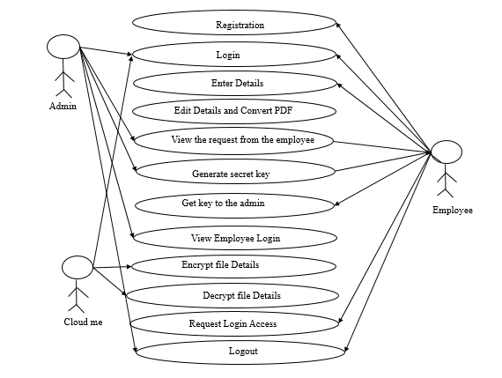

**Fig 3.1 Case diagram**

**3.2 SYSTEM ARCHITECTURE DIAGRAM:**

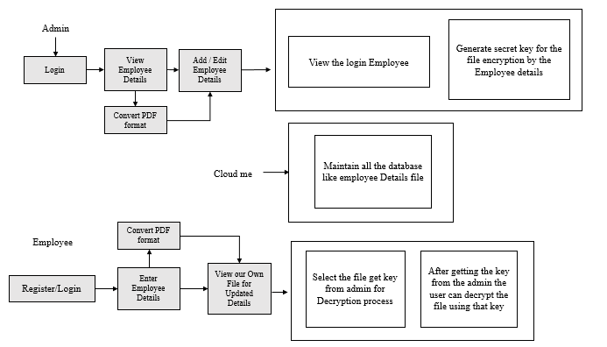

**Fig 3.2 System Architectural diagram**

**3.3 ER DIAGRAM:**

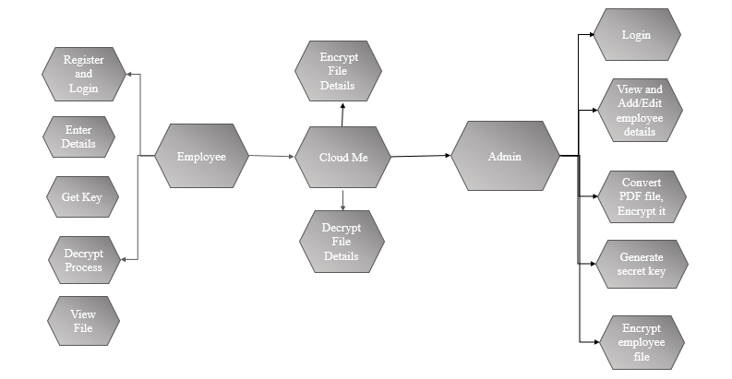

literature review of this paper is divided into three sub-

sections as per the detection of emotions with respect to different

sources. The ﬁrst sub-section discusses about the studies con-

ducted to detect depression through sentiment analysis of twitter

tweets. The second sub-section converse about detection of

depression using facial expression (image and video processing).

The last sub-section deals with the use of chatbots, emotional AI

and combined inputs (text, audio, image and video) for detecting

depression. All these sources to detect depression are discussed

in the terms of various machine learning techniques.

The literature review of this paper is divided into three sub-

sections as per the detection of emotions with respect to different

sources. The ﬁrst sub-section discusses about the studies con-

ducted to detect depression through sentiment analysis of twitter

tweets. The second sub-section converse about detection of

depression using facial expression (image and video processing).

The last sub-section deals with the use of chatbots, emotional AI

and combined inputs (text, audio, image and video) for detecting

depression. All these sources to detect depression are discussed

in the terms of various machine learning techniques.

**Fig 3.3 ER diagram**

**3.4 FLOW DIAGRAM:**

**Level 0:**

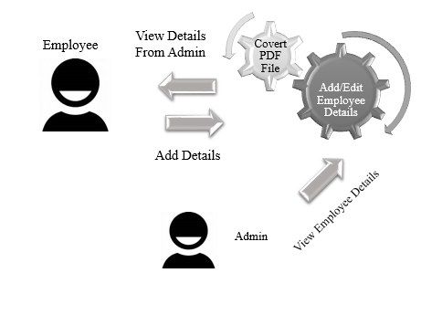

**Fig 3.4 Level 0**

**Level 1:**

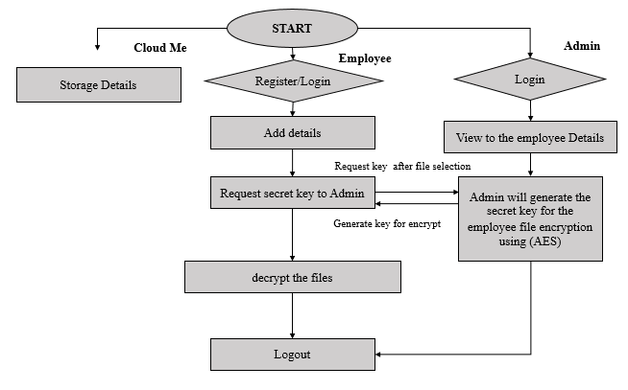

**Fig 3.5 Level 1**

**Level 2:**

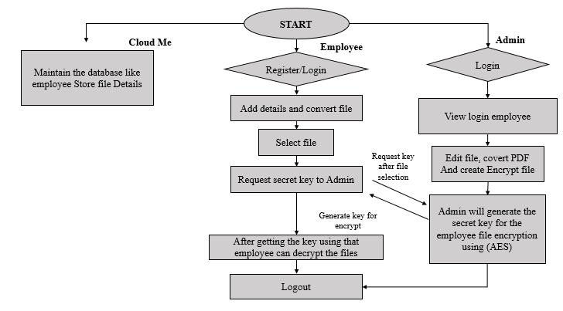

**Fig 3.6 Level 2**

**3.5 SEQUENCE DIAGRAM:**

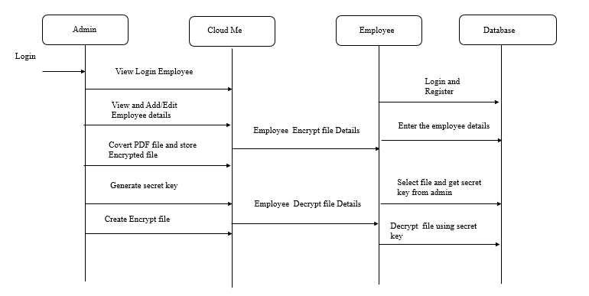

**Fig 3.7 Sequence Diagram**

**3.6 ACTIVITY DIAGRAM:**

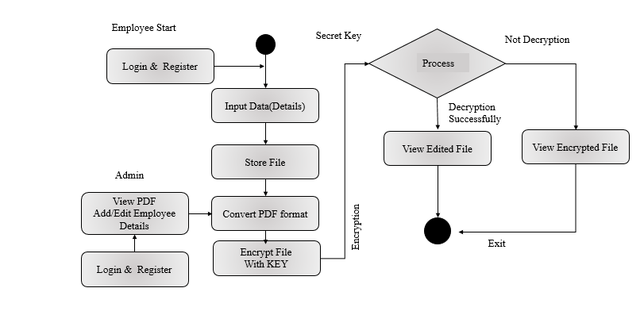

**Fig 3.8 Activity Diagram**

Anomaly detection in a dynamic data stream is a

challenging task. The endless bound and high arriving rate of

data prohibits anomaly detection models to store all observations

in memory for processing. In addition, the dynamically moving

properties of the data stream exhibit concept drift. While recent

studies focus on feature extraction for anomaly detection, major-

ity of them assume data stream are static ignoring the possibility

of concept drift occurring. Anomaly detection models must

operate efﬁciently in order to deal with high volume and velocity

data, that is to have low complexity and to learn incrementally

from each arriving observation. Incremental learning allows the

model to adapt to concept drift. In cases where drifting rate

is higher than adaptation rate, the capability to detect concept

drift and retraining a new model is much preferable to minimize

the performance losses. In this paper, we propose MIR MAD,

an approach based on multiple incremental robust Mahalanobis

estimators that is efﬁcient, learns incrementally and has the

capability to detect concept drift. MIR MAD is fast, can be

initialized with small amount of data, and is able to estimate

the drift location on the data stream. Our empirical results

show that MIR MAD achieves state-of-the-art performance and

is signiﬁcantly faster. We also performed a case study to show

that detecting concept drift is critical to minimize the reductio

Anomaly detection in a dynamic data stream is a

challenging task. The endless bound and high arriving rate of

data prohibits anomaly detection models to store all observations

in memory for processing. In addition, the dynamically moving

properties of the data stream exhibit concept drift. While recent

studies focus on feature extraction for anomaly detection, major-

ity of them assume data stream are static ignoring the possibility

of concept drift occurring. Anomaly detection models must

operate efﬁciently in order to deal with high volume and velocity

data, that is to have low complexity and to learn incrementally

from each arriving observation. Incremental learning allows the

model to adapt to concept drift. In cases where drifting rate

is higher than adaptation rate, the capability to detect concept

drift and retraining a new model is much preferable to minimize

the performance losses. In this paper, we propose MIR MAD,

an approach based on multiple incremental robust Mahalanobis

estimators that is efﬁcient, learns incrementally and has the

capability to detect concept drift. MIR MAD is fast, can be

initialized with small amount of data, and is able to estimate

the drift location on the data stream. Our empirical results

show that MIR MAD achieves state-of-the-art performance and

is signiﬁcantly faster. We also performed a case study to show

that detecting concept drift is critical to minimize the reductio

Anomaly detection in a dynamic data stream is a

challenging task. The endless bound and high arriving rate of

data prohibits anomaly detection models to store all observations

in memory for processing. In addition, the dynamically moving

properties of the data stream exhibit concept drift. While recent

studies focus on feature extraction for anomaly detection, major-

ity of them assume data stream are static ignoring the possibility

of concept drift occurring. Anomaly detection models must

operate efﬁciently in order to deal with high volume and velocity

data, that is to have low complexity and to learn incrementally

from each arriving observation. Incremental learning allows the

model to adapt to concept drift. In cases where drifting rate

is higher than adaptation rate, the capability to detect concept

drift and retraining a new model is much preferable to minimize

the performance losses. In this paper, we propose MIR MAD,

an approach based on multiple incremental robust Mahalanobis

estimators that is efﬁcient, learns incrementally and has the

capability to detect concept drift. MIR MAD is fast, can be

initialized with small amount of data, and is able to estimate

the drift location on the data stream. Our empirical results

show that MIR MAD achieves state-of-the-art performance and

is signiﬁcantly faster. We also performed a case study to show

that detecting concept drift is critical to minimize the reducti

Anomaly detection in a dynamic data stream is a

challenging task. The endless bound and high arriving rate of

data prohibits anomaly detection models to store all observations

in memory for processing. In addition, the dynamically moving

properties of the data stream exhibit concept drift. While recent

studies focus on feature extraction for anomaly detection, major-

ity of them assume data stream are static ignoring the possibility

of concept drift occurring. Anomaly detection models must

operate efﬁciently in order to deal with high volume and velocity

data, that is to have low complexity and to learn incrementally

from each arriving observation. Incremental learning allows the

model to adapt to concept drift. In cases where drifting rate

is higher than adaptation rate, the capability to detect concept

drift and retraining a new model is much preferable to minimize

the performance losses. In this paper, we propose MIR MAD,

an approach based on multiple incremental robust Mahalanobis

estimators that is efﬁcient, learns incrementally and has the

capability to detect concept drift. MIR MAD is fast, can be

initialized with small amount of data, and is able to estimate

the drift location on the data stream. Our empirical results

show that MIR MAD achieves state-of-the-art performance and

is signiﬁcantly faster. We also performed a case study to show

that detecting concept drift is critical to minimize the reductio

Anomaly detection in a dynamic data stream is a

challenging task. The endless bound and high arriving rate of

data prohibits anomaly detection models to store all observations

in memory for processing. In addition, the dynamically moving

properties of the data stream exhibit concept drift. While recent

studies focus on feature extraction for anomaly detection, major-

ity of them assume data stream are static ignoring the possibility

of concept drift occurring. Anomaly detection models must

operate efﬁciently in order to deal with high volume and velocity

data, that is to have low complexity and to learn incrementally

from each arriving observation. Incremental learning allows the

model to adapt to concept drift. In cases where drifting rate

is higher than adaptation rate, the capability to detect concept

drift and retraining a new model is much preferable to minimize

the performance losses. In this paper, we propose MIR MAD,

an approach based on multiple incremental robust Mahalanobis

estimators that is efﬁcient, learns incrementally and has the

capability to detect concept drift. MIR MAD is fast, can be

initialized with small amount of data, and is able to estimate

the drift location on the data stream. Our empirical results

show that MIR MAD achieves state-of-the-art performance and

is signiﬁcantly faster. We also performed a case study to show

that detecting concept drift is critical to minimize t

**3.7. CLASS DIAGRAM:**

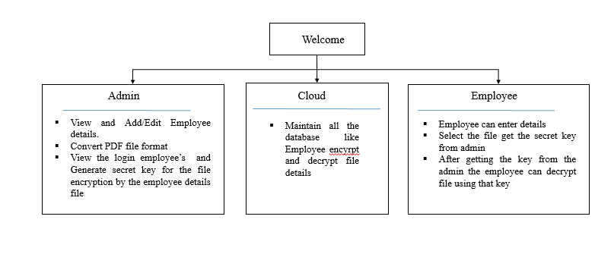

**Fig 3.9 Class Diagram**

The figure 3.1, 3.2, 3.3, 3.4, 3.5, 3.6, 3.7, 3.8, 3.9 diagram shows the Employee can enter with login USERNAME and Password to connect the frame. Once enter the frame to fill-up the given details. Make a file to view the admin point of view. That file edited by admin and process on cryptographic function for our file security. The encrypted only view with secret key only that key given by admin to employee. Employee can view edited file from admin for better clarification.

**CHAPTER-4**

**IMPLEMENTATION**

**4.1 MODULES:**

* Employee
* Admin

**4.2 MODULES DESCRIPTION:**

**4.2.1 EMPLOYEE**

* Employee have the registration process after that it goes to the admin part for access.
* After that updating details and covert file, it will move to the next part of process.
* Then the employee will select the file for view our ID or other details. Authorized employee view her/his own file otherwise only enter and encrypt the file from employee side.
* It will send key request to the admin.
* After getting the key from the admin the employee can download the own file using that key for view her/his details.

**4.2.2 ADMIN**

* Admin also have the login verification process.
* Admin will give the access for the user to login.
* And add or edit employee details and covert PDF format.
* Also the secret key for the file to the employee will be generated by the admin.

**CHAPTER 5**

**SYSTEM REQUIREMENTS**

**5.1 HARDWARE REQUIREMENTS:**

* Processor  **:** Intel Core i5
* Hard Disk **:**  200 GB
* Monitor **:** 18’ LED color
* Mouse **:** DELL.
* Keyboard **:** 110 keys enhanced
* RAM  **:** 3GB

**5.2 SOFTWARE REQUIREMENTS:**

* Operating System  **:** Windows 7 / 8 / 10
* Language Used **:** Java
* Database **:**  My SQL
* User Interface Design  **:** JFrame
* Server **:** Xampp_server
* Software **:** NetBeans IDE 21

**5.3 SOFTWARE DESCRIPTION:**

* + 1. **Java**

Java is a programming language originally developed by James Gosling at Sun Microsystems (now a subsidiary of Oracle Corporation) and released in 1995 as a core component of Sun Microsystems' Java platform. The language derives much of its syntax from C and C++ but has a simpler object model and fewer low-level facilities. Java applications are typically compiled to byte code (class file) that can run on any Java Virtual Machine (JVM) regardless of computer architecture. Java is a general-purpose, concurrent, class-based, object-oriented language that is specifically designed to have as few implementation dependencies as possible. It is intended to let application developers "write once, run anywhere." Java is currently one of the most popular programming languages in use, particularly for client-server web applications.

* **Java Platform**

One characteristic of Java is portability, which means that computer programs written in the Java language must run similarly on any hardware/operating-system platform. This is achieved by compiling the Java language code to an intermediate representation called Java byte code, instead of directly to platform-specific machine code. Java byte code instructions are analogous to machine code, but are intended to be interpreted by a virtual machine (VM) written specifically for the host hardware.

End-users commonly use a Java Runtime Environment (JRE) installed on their own machine for standalone Java applications, or in a Web browser for Java applets. Standardized libraries provide a generic way to access host-specific features such as graphics, threading, and networking.

A major benefit of using byte code is porting. However, the overhead of interpretation means that interpreted programs almost always run more slowly than programs compiled to native executable would. Just-in-Time compilers were introduced from an early stage that compiles byte codes to machine code during runtime.

Just as application servers such as Glass Fish provide lifecycle services to web applications, the Net Beans runtime container provides them to Swing applications. All new shortcuts should be registered in "Key maps/Net Beans" folder. Shortcuts installed INS Shortcuts folder will be added to all key maps, if there is no conflict. It means that if the same shortcut is mapped to different actions in Shortcut folder and current key map folder (like Key map/Net Beans), the Shortcuts folder mapping will be ignored.

* + Database Explorer Layer API in Database Explorer
  + Loaders-images-dB schema-Actions in Database Explorer
  + Loaders-images-sq.-Actions in Database Explorer
  + Plug-in Registration in Java EE Server Registry

The keyword public denotes that a method can be called from code in other classes, or that a class may be used by classes outside the class hierarchy. The class hierarchy is related to the name of the directory in which the .java file is located.

The keyword static in front of a method indicates a static method, which is associated only with the class and not with any specific instance of that class. Only static methods can be invoked without a reference to an object. Static methods cannot access any class members that are not also static. The keyword void indicates that the main method does not return any value to the caller. If a Java program is to exit with an error code, it must call System. Exit () explicitly.

The method name "main" is not a keyword in the Java language. It is simply the name of the method the Java launcher calls to pass control to the program. Java classes that run in managed environments such as applets and Enterprise JavaBeans do not use or need a main () method. A Java program may contain multiple classes that have main methods, which means that the VM needs to be explicitly told which class to launch from.

The Java launcher launches Java by loading a given class (specified on the command line or as an attribute in a JAR) and starting its public static void main(String[]) method. Stand-alone programs must declare this method explicitly. The String [] rags parameter is an array of String objects containing any arguments passed to the class. The parameters to main are often passed by means of a command line.

* **Java a High-level Language**

A high-level programming language developed by Sun Microsystems. Java was originally called OAK, and was designed for handheld devices and set-top boxes. Oak was unsuccessful so in 1995 Sun changed the name to Java and modified the language to take advantage of the burgeoning World Wide Web.

Java source code files (files with a .java extension) are compiled into a format called byte code (files with a .class extension), which can then be executed by a Java interpreter. Compiled Java code can run on most computers because Java interpreters and runtime environments, known as Java Virtual Machines (VMs). Byte code can also be converted directly into machine language instructions by a just-in-time compiler (JIT).

Java is a general purpose programming language with a number of features that make the language well suited for use on the World Wide Web. Small Java applications are called Java applets and can be downloaded from a Web server and run on your computer by a Java-compatible Web browser, such as Netscape Navigator or Microsoft Internet Explorer.

Object-Oriented Software Development using Java: Principles, Patterns, and Frameworks contain a much applied focus that develops skills in designing software-particularly in writing well-designed, medium-sized object-oriented programs. It provides a broad and coherent coverage of object-oriented technology, including object-oriented modeling using the Unified Modeling Language (UML) object-oriented design using Design Patterns, and object-oriented programming using Java.

* **Net Beans**

The **Net Beans Platform** is a reusable framework for simplifying the development of Java Swing desktop applications. The Net Beans IDE bundle for Java SE contains what is needed to start developing Net Beans plug-in and Net Beans Platform based applications; no additional SDK is required.

Applications can install modules dynamically. Any application can include the Update Center module to allow users of the application to download digitally-signed upgrades and new features directly into the running application.

The platform offers reusable services common to desktop applications, allowing developers to focus on the logic specific to their application. Among the features of the platform are:

* User interface management (e.g. menus and toolbars)
* User settings management
* Storage management (saving and loading any kind of data)
* Window management
* Wizard framework (supports step-by-step dialogs)
* Net Beans Visual Library
* Integrated Development Tools

**J2EE**

A **Java EE application** or a **Java Platform, Enterprise Edition application** is any deployable unit of Java EE functionality. This can be a single Java EE module or a group of modules packaged into an EAR file along with a Java EE application deployment descriptor.

Enterprise applications can consist of the following:

* EJB modules (packaged in JAR files)
* Web modules (packaged in WAR files)
* connector modules or resource adapters (packaged in RAR files)
* Session Initiation Protocol (SIP) modules (packaged in SAR files)
* application client modules
* Additional JAR files containing dependent classes or other components required by the application.

**Xampp Server**

* **XAMP**s are packages has the ability to serve web pages on World Wide Web.
* Apache is a web server. MySQL is an open-source database. PHP is a scripting language that can manipulate information held in a database and generate web pages dynamically each time content is requested by a browser. Other programs may also be included in a package, such as phpMyAdmin which provides a graphical user interface for the MySQL database manager, or the alternative scripting languages Python or Perl.

**MySQL**

* The MySQL development project has made its source code available under the terms of the GNU General Public License, as well as under a variety of proprietary agreements. MySQL was owned and sponsored by a single for-profit firm, the Swedish company MySQL AB, now owned by Oracle Corporation.
* Free-software-open source projects that require a full-featured database management system often use MySQL. Applications which use MySQL databases include: TYPO3, Joomla, WordPress, hob, Drupal and other software built on the LAMP software stack.

**Platforms and interfaces**

* Many programming languages with language-specific APIs include libraries for accessing MySQL databases. These include MySQL Connector/Net for integration with Microsoft's Visual Studio (languages such as C# and VB are most commonly used) and the JDBC driver for Java. In addition, an ODBC interface called Modoc allows additional programming languages that support the ODBC interface to communicate with a MySQL database, such as ASP or ColdFusion. The MySQL server and official libraries are mostly implemented in ANSI C/ANSI C++.

**5.4 TESTING PRODUCTS:**

System testing is the stage of implementation, which aimed at ensuring that system works accurately and efficiently before the live operation commence. Testing is the process of executing a program with the intent of finding an error. A good test case is one that has a high probability of finding an error. A successful test is one that answers a yet undiscovered error.

Testing is vital to the success of the system. System testing makes a logical assumption that if all parts of the system are correct, the goal will be successfully achieved. . A series of tests are performed before the system is ready for the user acceptance testing. Any engineered product can be tested in one of the following ways. Knowing the specified function that a product has been designed to from, test can be conducted to demonstrate each function is fully operational. Knowing the internal working of a product, tests can be conducted to ensure that “al gears mesh”, that is the internal operation of the product performs according to the specification and all internal components have been adequately exercised.

**5.4.1 UNIT TESTING:**

Unit testing is the testing of each module and the integration of the overall system is done. Unit testing becomes verification efforts on the smallest unit of software design in the module. This is also known as ‘module testing’. The modules of the system are tested separately. This testing is carried out during the programming itself. In this testing step, each model is found to be working satisfactorily as regard to the expected output from the module. There are some validation checks for the fields. For example, the validation check is done for verifying the data given by the user where both format and validity of the data entered is included. It is very easy to find error and debug the system.

**5.4.2 INTEGRATION TESTING**

Data can be lost across an interface, one module can have an adverse effect on the other sub function, when combined, may not produce the desired major function. Integrated testing is systematic testing that can be done with sample data. The need for the integrated test is to find the overall system performance. There are two types of integration testing. They are:

1. Top-down integration testing.
2. Bottom-up integration testing.

**5.4.3 TESTING TECHNIQUES/STRATEGIES:**

* **BLACK BOX TESTING:**

1. Black box testing is done to find incorrect or missing function
2. Interface error
3. Errors in external database access
4. Performance errors.
5. Initialization and termination errors

In ‘functional testing’, is performed to validate an application conforms to its specifications of correctly performs all its required functions. So this testing is also called ‘black box testing’. It tests the external behaviour of the system. Here the engineered product can be tested knowing the specified function that a product has been designed to perform, tests can be conducted to demonstrate that each function is fully operational.

* **WHITE BOX TESTING:**

White Box testing is a test case design method that uses the control structure of the procedural design to drive cases. Using the white box testing methods, we Derived test cases that guarantee that all independent paths within a module have been exercised at least once.

**5.4.4 SOFTWARE TESTING STRATEGIES**

**VALIDATION TESTING:**

* After the culmination of black box testing, software is completed assembly as a package, interfacing errors have been uncovered and corrected and final series of software validation tests begin validation testing can be defined as many,
* But a single definition is that validation succeeds when the software functions in a manner that can be reasonably expected by the customer

**USER ACCEPTANCE TESTING:**

User acceptance of the system is the key factor for the success of the system. The system under consideration is tested for user acceptance by constantly keeping in touch with prospective system at the time of developing changes whenever required.

**OUTPUT TESTING**:

After performing the validation testing, the next step is output asking the user about the format required testing of the proposed system, since no system could be useful if it does not produce the required output in the specific format. The output displayed or generated by the system under consideration. Here the output format is considered in two ways. One is screen and the other is printed format. The output format on the screen is found to be correct as the format was designed in the system phase according to the user needs. For the hard copy also output comes out as the specified requirements by the user. Hence the output testing does not result in any connection in the system.

**CHAPTER 6**

**CONCLUSION**

* In conclusion, employee management systems play a crucial role in streamlining human resources processes, improving efficiency, and enhancing overall organizational performance. While they offer significant benefits, such as centralized data management, improved communication, and enhanced reporting capabilities, it’s essential to weigh these advantages against potential drawbacks.
* It also cuts down compliance and regulatory risks.
* Though, the lack of standards for implementation and technology varies, making it tough to compare vendors.
* Continuous evaluation and adaptation of the system will further enhance its value, ensuring it evolves with the organization's goals and workforce dynamics.

**CHAPTER 7**

**FUTURE ENHANCEMENT**

* With the increasing reliance on mobile devices, enhancing systems for mobile access will allow employees to manage their information and communicate with ADMIN from anywhere.
* Incorporating features that support mental health and work-life balance, such as wellness programs, flexible scheduling, and feedback mechanisms, can create a more supportive work environment.
* Implementing tools for continuous feedback and performance tracking can foster open communication and help employees align with organizational goals.

**CHAPTER 8**

**SAMPLE CODING**

**VIEW PAGE CODE**

package employe_management;

import java.io.IOException;

import java.io.FileWriter;

import java.io.Writer;

import java.sql.Connection;

import java.sql.DriverManager;

import java.sql.ResultSet;

import java.sql.ResultSetMetaData;

import java.sql.Statement;

import java.util.Vector;

import javax.swing.JOptionPane;

import java.sql.SQLException;

import java.util.logging.Level;

import java.util.logging.Logger;

import javax.swing.JTextField;

import java.io.PrintWriter;

import java.sql.PreparedStatement;

import javax.swing.table.DefaultTableModel;

public class view extends javax.swing.JFrame {

Vector columnNames =new Vector();

Vector data1=new Vector();

Vector columnNames1 = new Vector();

Vector data2 = new Vector();

DefaultTableModel model,model1;

private String uname;

private String Address;

private String Certifications;

private String Name;

private String Skills;

private String Relationship;

private String Position;

private String PhoneNo;

private String Phone;

private String HireDate;

private String EmailID;

private String Department;

private String DateofBirth;

public view() {

initComponents();

}

@SuppressWarnings("unchecked")

// <editor-fold defaultstate="collapsed" desc="Generated Code">

private void initComponents() {

jPanel1 = new javax.swing.JPanel();

jScrollPane1 = new javax.swing.JScrollPane();

jTable1 = new javax.swing.JTable();

jButton1 = new javax.swing.JButton();

jButton3 = new javax.swing.JButton();

jLabel1 = new javax.swing.JLabel();

jButton4 = new javax.swing.JButton();

jLabel2 = new javax.swing.JLabel();

setDefaultCloseOperation(javax.swing.WindowConstants.EXIT_ON_CLOSE);

getContentPane().setLayout(new org.netbeans.lib.awtextra.AbsoluteLayout());

jPanel1.setLayout(new org.netbeans.lib.awtextra.AbsoluteLayout());

jTable1.setModel(new javax.swing.table.DefaultTableModel(

new Object [][] {

},

new String [] {

""

}

));

jScrollPane1.setViewportView(jTable1);

jPanel1.add(jScrollPane1, new org.netbeans.lib.awtextra.AbsoluteConstraints(80, 150, 540, 270));

jButton1.setFont(new java.awt.Font("Times New Roman", 1, 18)); // NOI18N

jButton1.setText("VIEW");

jButton1.addActionListener(new java.awt.event.ActionListener() {

public void actionPerformed(java.awt.event.ActionEvent evt) {

jButton1ActionPerformed(evt);

}

});

jPanel1.add(jButton1, new org.netbeans.lib.awtextra.AbsoluteConstraints(80, 440, 540, 40));

jButton3.setFont(new java.awt.Font("Times New Roman", 1, 18)); // NOI18N

jButton3.setText("BACK");

jButton3.addActionListener(new java.awt.event.ActionListener() {

public void actionPerformed(java.awt.event.ActionEvent evt) {

jButton3ActionPerformed(evt);

}

});

jPanel1.add(jButton3, new org.netbeans.lib.awtextra.AbsoluteConstraints(80, 100, 170, 40));

jLabel1.setFont(new java.awt.Font("Times New Roman", 1, 36)); // NOI18N

jLabel1.setForeground(new java.awt.Color(255, 255, 255));

jLabel1.setText("VIEW DATA");

jPanel1.add(jLabel1, new org.netbeans.lib.awtextra.AbsoluteConstraints(260, 20, 225, 35));

jButton4.setFont(new java.awt.Font("Times New Roman", 1, 18)); // NOI18N

jButton4.setText("NEXT");

jButton4.addActionListener(new java.awt.event.ActionListener() {

public void actionPerformed(java.awt.event.ActionEvent evt) {

jButton4ActionPerformed(evt);

}

});

jPanel1.add(jButton4, new org.netbeans.lib.awtextra.AbsoluteConstraints(450, 100, 170, 40));

jLabel2.setIcon(new javax.swing.ImageIcon(getClass().getResource("/img/img7.jpg"))); // NOI18N

jPanel1.add(jLabel2, new org.netbeans.lib.awtextra.AbsoluteConstraints(0, 0, -1, -1));

getContentPane().add(jPanel1, new org.netbeans.lib.awtextra.AbsoluteConstraints(0, 0, 710, 530));

pack();

setLocationRelativeTo(null);

}// </editor-fold>

private void jButton4ActionPerformed(java.awt.event.ActionEvent evt) {

this.setVisible(false);

new adminaction().setVisible(true); // TODO add your handling code here:

}

private void jButton3ActionPerformed(java.awt.event.ActionEvent evt) {

this.setVisible(false);

new admin().setVisible(true);

}

private void jButton1ActionPerformed(java.awt.event.ActionEvent evt) {

try

{

Class.forName("com.mysql.cj.jdbc.Driver");

Connection con = DriverManager.getConnection("jdbc:mysql://localhost:3306/employee_data", "root", "");

Statement stmt = con.createStatement();

Statement stmt2 = con.createStatement();

ResultSet rs2 = stmt2.executeQuery("SELECT * FROM em");

ResultSetMetaData rsmd = rs2.getMetaData();

int columns = rsmd.getColumnCount();

for(int i=1;i<=columns;i++)

{

columnNames1.addElement(rsmd.getColumnName(i));

}

while(rs2.next())

{

Vector row=new Vector(columns);

for(int i=1;i<=columns;i++)

{

row.addElement(rs2.getObject(i));

}

data2.addElement(row);

}

rs2.close();

model1=new DefaultTableModel(data2, columnNames1);

jTable1.setModel(model1);

}

catch(Exception e)

{

JOptionPane.showMessageDialog(this, e);

}

}

public static void main(String args[]) {

java.awt.EventQueue.invokeLater(new Runnable() {

public void run() {

new view().setVisible(true);

}

});

}

// Variables declaration - do not modify

private javax.swing.JButton jButton1;

private javax.swing.JButton jButton3;

private javax.swing.JButton jButton4;

private javax.swing.JLabel jLabel1;

private javax.swing.JLabel jLabel2;

private javax.swing.JPanel jPanel1;

private javax.swing.JScrollPane jScrollPane1;

private javax.swing.JTable jTable1;

// End of variables declaration

**CHAPTER 9**

**SAMPLE SCREENSHOTS**

**WELCOME PAGE**

**Fig 1: Wellcome Page**

**INDEX PAGE**



**Fig 2: Index Page**

**EMPLOYEE REGISTRATION / LOGIN**



**Fig 3: Employee Register Page**

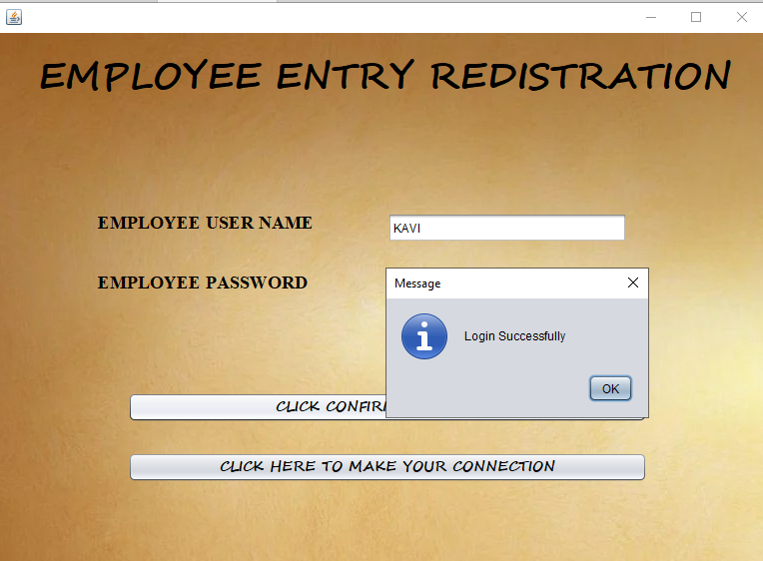

**Fig 4: Employee Login Page**

**EMPLOYEE DETAILS ADD PAGE:**



**Fig 5: Employee Page**



**Fig 6: Employee Details Add Page**

**GENERATE FILE WITH ADDED DETAILS:**

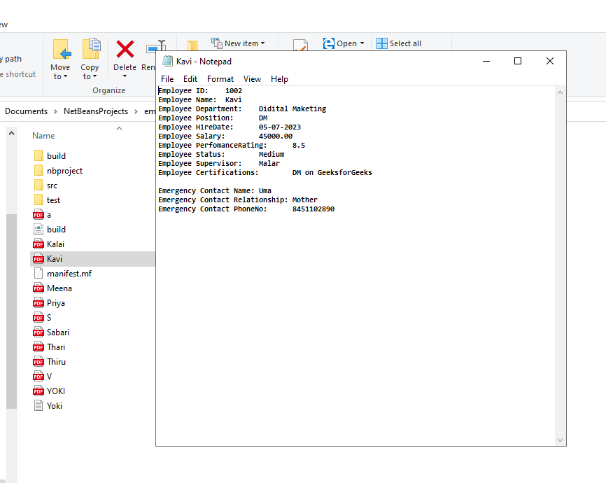

**Fig7: Employee Details File Page**

**ADMIN LOGIN:**



**Fig 9: Admin Login Page**



**Fig 10: Admin Use Page**

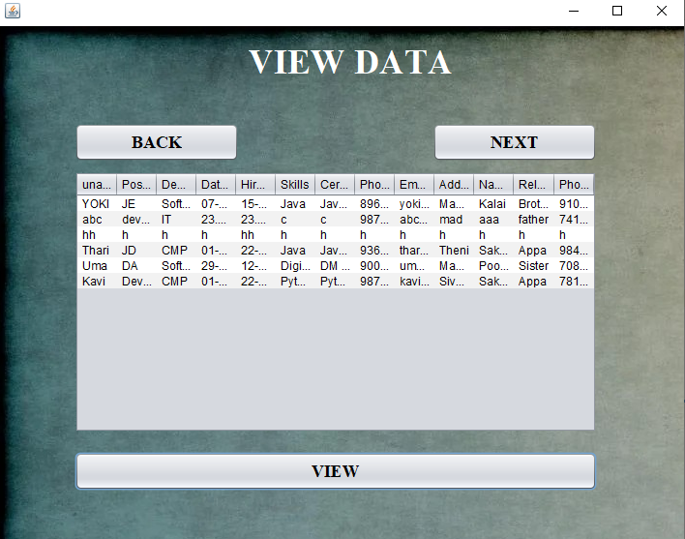

**Fig 11: Admin View Page**

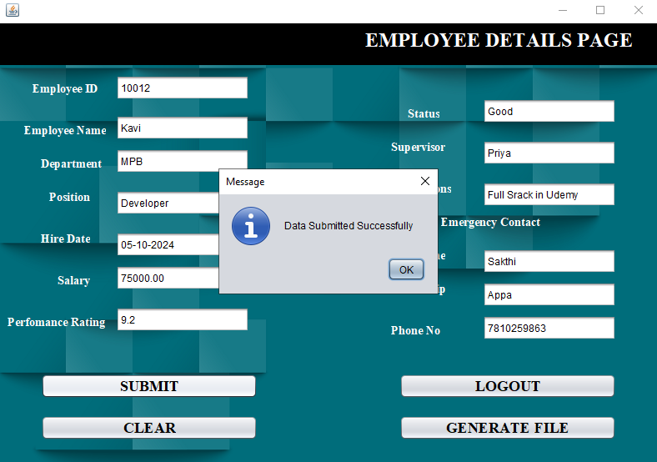

**Fig 12: Admin View & Edit Employee Details Page**

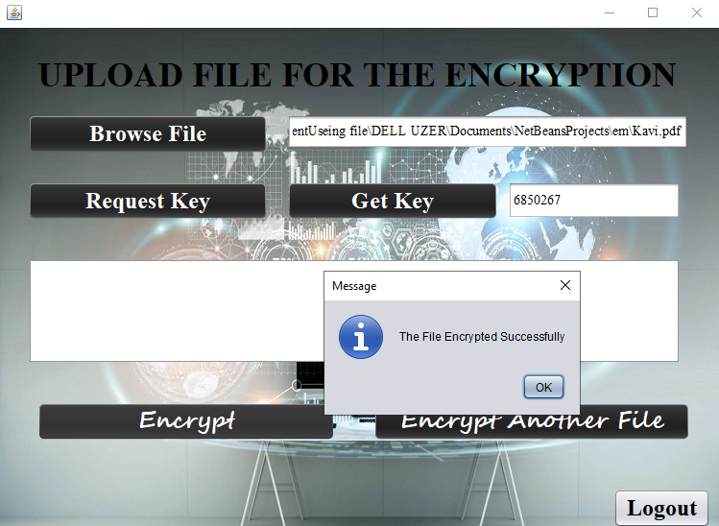

**Fig 13: Admin Encrypt Edited Employee Details Page**

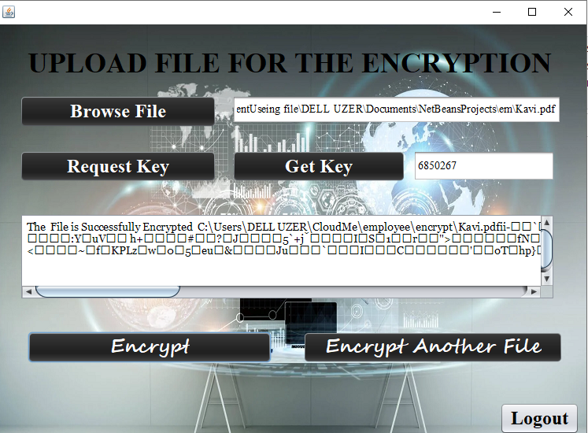

**Fig 14: Encrypted Employee Details File Page**

**EMPLOYEE PAGE:**



**Fig 15: Employee Go To View Encrypt File Page**

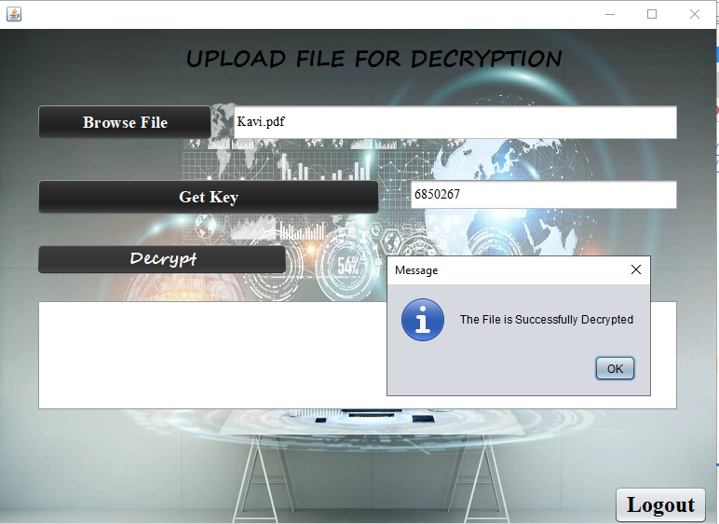

**Fig 16: Employee Choose File for Encrypt Page**

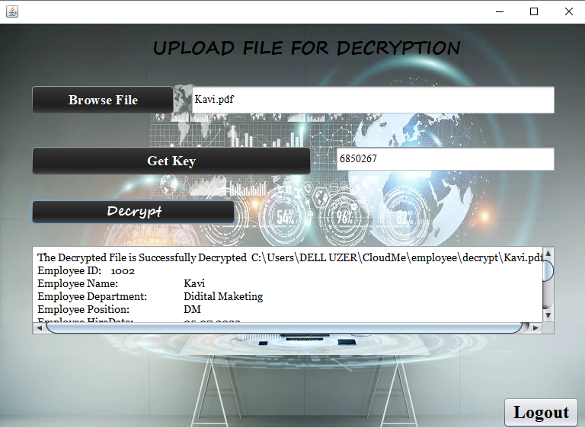

**Fig 17: Employee View Decrypt File Page**



**Fig 18: Encrypt File on Cloud Me Page**

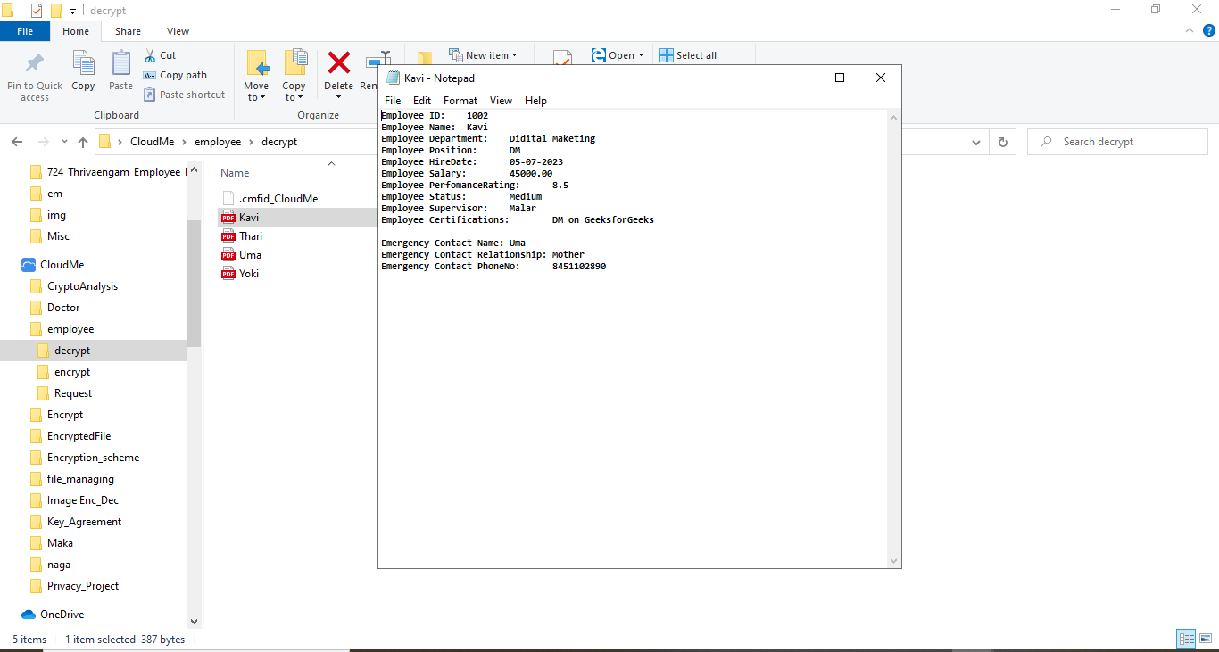

**Fig 19: Decrypt File on Cloud Me Page**

**CHAPTER 10**

**REFERENCES**

1. Tannady, H., Dewi, C. S., & Gilbert. (2024). Exploring Role of Technology Performance Expectancy, Application Effort Expectancy, Perceived Risk and Perceived Cost On Digital Behavioral Intention of GoFood Users. Jurnal Informasi Dan Teknologi, 6(1), 80-85. https://doi.org/10.60083/jidt.v6i1.477
2. Yumhi, Y., & Noor, J. (2022). Entrepreneurıal Orıentatıon and Transformatıonal Leadershıp As Determınants of Employee Creatıvıty: The Medıatıng Role of Knowledge Sharıng. APMBA (Asia Pacific Management and Business Application), 10(3), 307-318.
3. Noor, J., Tunnufus, Z., Handrian, V. Y., & Yumhi, Y. (2023). Green human resources management practices, leadership style and employee engagement: Green banking context. Heliyon, 9(12).
4. annady, H., Andry, J. F., & Nurprihatin, F. (2020, March). Determinants factors toward the performance of the employee in the crude palm oil industry in West Sumatera, Indonesia. In IOP Conference Series: Materials Science and Engineering (Vol. 771, No. 1, p. 012066). IOP Publishing.
5. Chen, Z., & Xu, X, "Study on Construction of Knowledge Management System Based on Enhancing Core Competence of Industrial Clusters," International Journal of Business and Management, vol. 5, no. 3, pp. 217–222, 2020.
6. Nurprihatin, F., Jayadi, E. L., & Tannady, H. (2020). Comparing heuristic methods' performance for pure flow shop scheduling under certainand uncertain demand. Management and production engineering review.
7. Lestari, A. S., & Hamka, S. R, "Analysis of the Components of Knowledge Management on the Postgraduate IAIN Kendari," Advances in Social Science, Education and Humanities Research, vol. 261, pp. 19–22, 2018.
8. Nawawi, I, "Knowledge Management: Theory and Application in Realizing the Competitiveness of Business and Public Organizations," Bogor: Ghalia Indonesia, 2022.
9. Fajariah, F., Saragih, H., Dharmawan, D., Judijanto, L., & Munizu, M. (2023). Application of Principal Component Analysis and Maximum Likelihood Estimation Method to Identify the Determinant Factors Intention to Use of Paylater in E-Commerce. Jurnal Informasi dan Teknologi, 118-123.
10. Dharmawan, D., Judijanto, L., Rahmi, N., & Lotte, L. N. A. (2023). Analysis Of The Influence Of E-Word Of Mouth, Brand Image And E-Service Quality On Repurchase Intention Of Digital Bank Customers. JEMSI (Jurnal Ekonomi, Manajemen, dan Akuntansi), 9(6), 2606-2612.
11. Akbar, Y, "Knowledge Management System at the Academic Administration Bureau of the Nusantara Tourism Academy," String, vol. 3, no. 1, pp. 87–97, 2018.
12. Yumhi, Y., & Noor, J. (2022). Entrepreneurıal Orıentatıon and Transformatıonal Leadershıp As Determınants of Employee Creatıvıty: The Medıatıng Role of Knowledge Sharıng. APMBA (Asia Pacific Management and Business Application), 10(3), 307-318.
13. S. Budi Utomo, J. P. Nugraha, E. Sri wahyuningsih, R. . Indrapraja, and F. A. . Binsar Kristian Panjaitan, “Analysis of The Effectiveness of Integrated Digital Marketing Communication Strategies in Building MSMEs Brand Awareness Through Social Media”, jsisfotek, vol. 5, no. 4, pp. 8–13, Oct. 2023.
14. A. Faridhatul Ulva, D. Abdullah, Masriadi, Nurhasanah, N. Alimul Haq, and B. Ulumul Haq, “AROS(AgRO-Smart) : Smart City Pertanian dengan Track and Trace GPS berbasis Mobile”, jidt, vol. 5, no. 4, pp. 78-91, Nov. 2023.
15. Hasanun, D. Abdullah, and M. Daud, “Pengembangan Sistem E-Learning Politeknik Negeri Lhokseumawe dengan Model Vark ”, jidt, vol. 5, no. 4, pp. 222-228, Dec. 2023.
16. D. Abdullah, “Perancangan Sistem Informasi Pelayanan Kapal,” J. Ilm. Teknol. Inf. Terap., 2015.
17. Gunawan, F. E., Wilujeng, F. R., Rembulan, G. D., & Tannady, H. (2020). Service quality analysis of smes tempe in province of Jakarta, Indonesia. Technology Reports of Kansai University, 62(7), 3827-3833.
18. Sapruwan, M, “The Role of Knowledge Management in Developing Financial Reports on Palm Oil Plantations,” Jurnal Citra Widya Edukasi, vol. 9, no. 1, pp. 40–53, 2017.
19. Application of Principal Component Analysis and Maximum Likelihood Estimation Method to Identify the Determinant Factors Intention to Use of Paylater in E-Commerce. Jurnal Informasi dan Teknologi, 118-123.
20. Chen, Z., & Xu, X, "Study on Construction of Knowledge Management System Based on Enhancing Core Competence of Industrial Clusters," International Journal of Business and Management, vol. 5, no. 3, pp. 217–222, 2020.

THANK YOU...